**White liquor oxidation process**

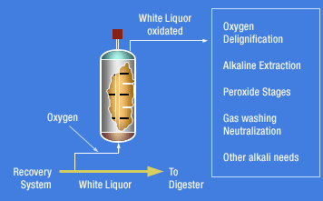In the white liquor oxidation process, the nitrogen sulfide (Na2S) in the white liquor is oxidized by air to polysulfides, which are used in the digestion process. The digestion process is where cellulose and semi-cellulose (polysaccharide) are separated from the chips which serve as the wood material for making pulp. White liquor being a chemical such as Na2S, NaOH etc.

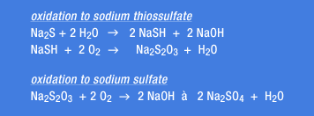

This air-oxidation process is situated in between the caustification process and the digestion process. The white liquor that is to be air-oxidized is taken from the line that connects the caustification to the digestion process, and the polysulfides generated are channeled back into process. This means that no modification to the existing system is necessary. The air-oxidation process is comprised mainly of a white-liquor filtration device and an oxidation reactor. The upper-current type is used in order for the filter to efficiently remove the SS, the major components being CaCO3 and other substances

generated during the caustification process. The oxidation reactor is filled with oxidation catalysts, then air supplied via a blower keeps the oxidation reaction going.

The NaOH generated along with the polysulfides in the reaction is used effectively in the digestion process, which also serves to reduce the load placed on the caustification process.

**Carmichael method**

In Carmichael’s apparatus, an asbestos diaphragm, impregnated with Portland cement, is used. The diaphragm rests horizontally on the cathode at the bottom of the cell; above it is a bell to collect the hydrogen given off. On anode is a grating of copper rods, covered with hard rubber, through which platinum points project into the brine. This anode is suspended in the top of the cell, and the chlorine set free is thus only momentarily in contact with the liquid. The salt solution is fed into the cell at the top, in a rapid stream of drops while the mixture of caustic soda and salt flows continuously from the bottom. The supply of brine is so regulated that the caustic formed at the cathode is drawn off before it has time to diffuse through the liquid. The solution drawn from the cell contains about 20 per cent of caustic soda, and about 75 per cent of the salt is decomposed. The reaction is carried on at a temperature of about 80° C in the top of the cell near the anode, while the region around the cathode is kept as cool as possible.

Being removed from the immediate action of the chlorine, the diaphragms are very durable.